**Laboratory Assignment 2: Transistors as Switches**

**ECE 0201: Digital Circuits and Systems**

**45 Points**

**Name**

谢君泽 Gabriel 0374 & 张鹤扬 Stefen 0349

**Submission Checklist:**

 Write within boxes, do not move boxes

 Write your full name in the box above

 Save this file as a PDF before uploading, keep the number of pages (**13**) unchanged

 Note “TO BE CONTINUED” in the answer box if you used the extra pages (11-13)

**Part I: Building a General Logic Source (1 point)**

[(A) Insert a picture of your build of the circuit in Figure 1] (0.5 points)

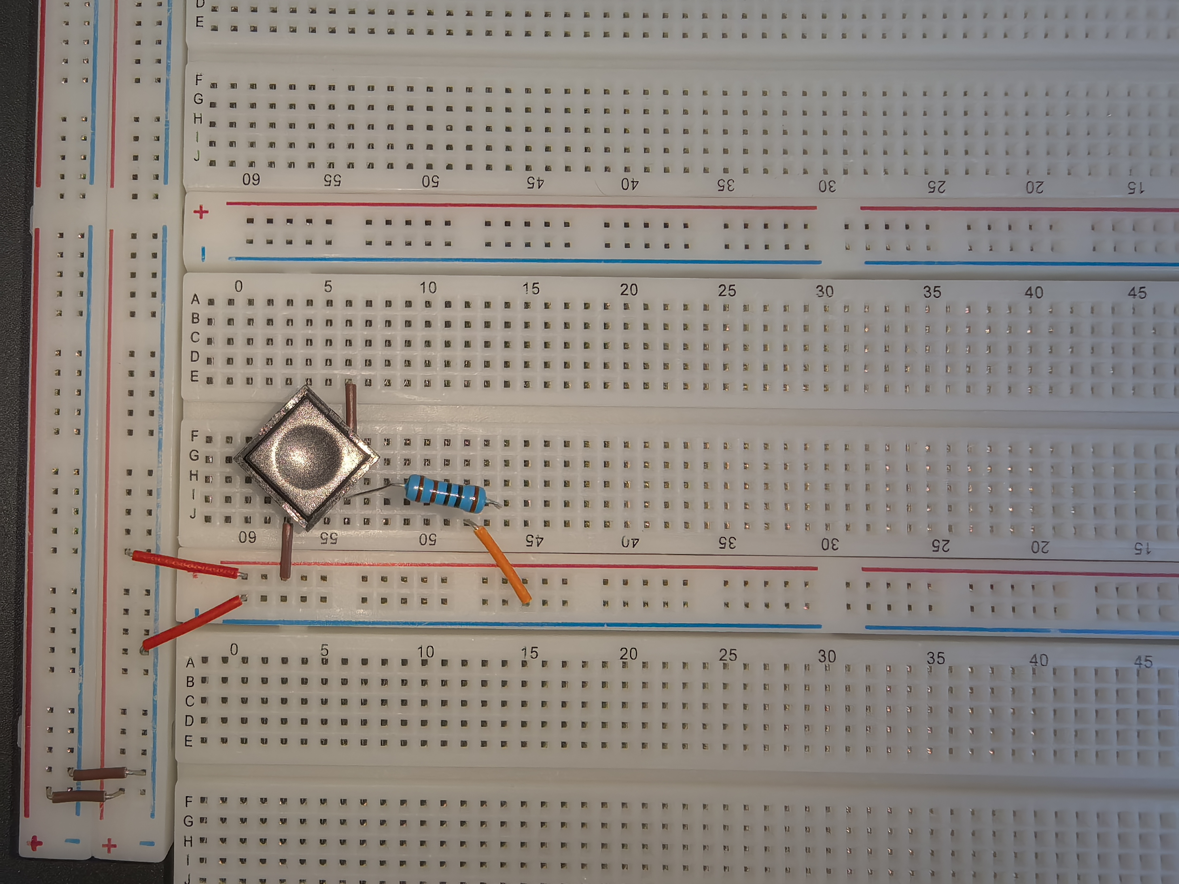

[(B) Fill out the following information] (0.5 point)

Vx when the switch is closed = 4.9978V

Vx when the switch is opened = -0.038mV

**Part II: The NMOS Inverter (9 points)**

[(A) Insert a picture of your build of the circuit in Figure 6] (0.5 points)

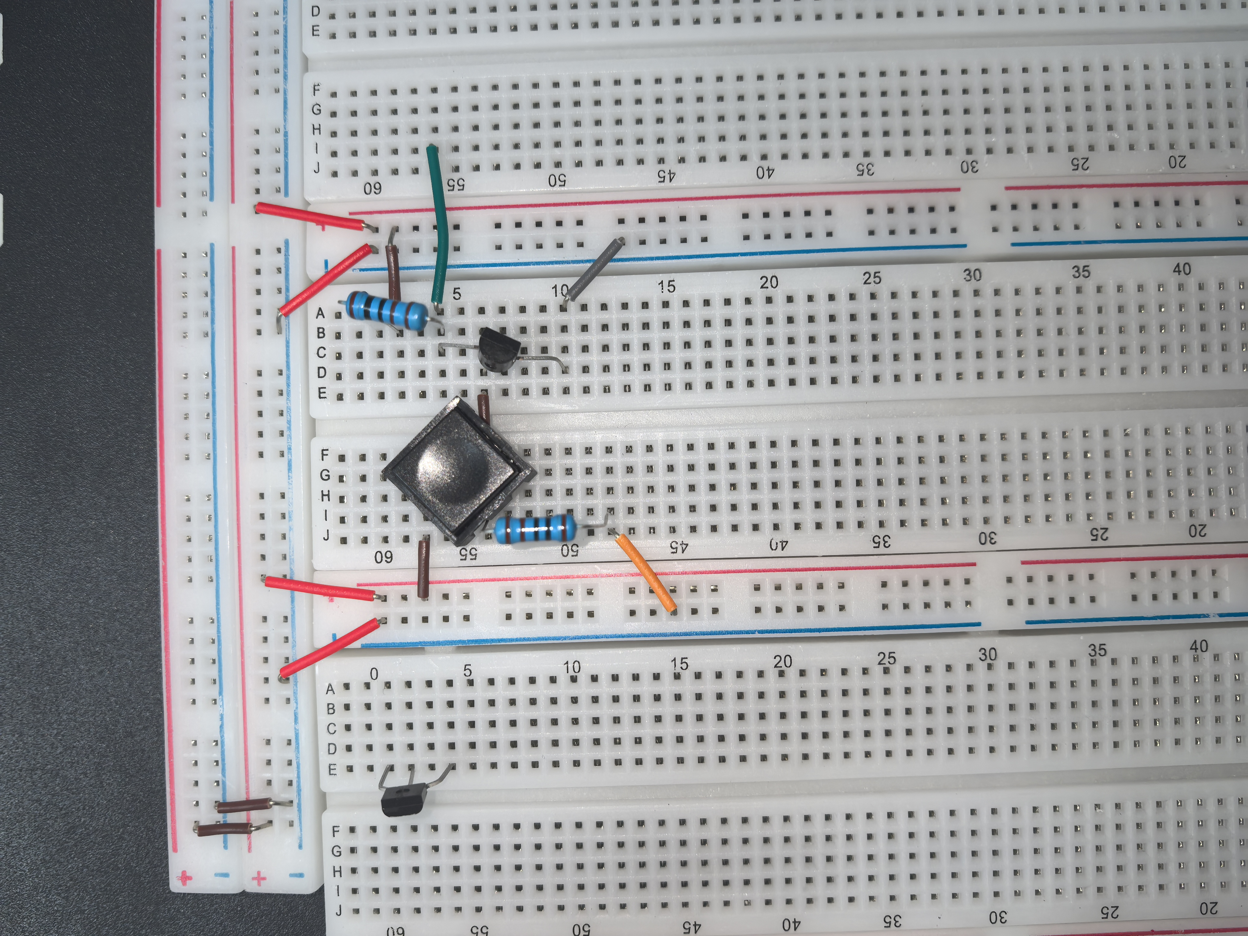

[(B) Fill out the following information] (1.0 points)

|  |  |  |  |
| --- | --- | --- | --- |
| S1 | Vin | Vout | LED (on/off) |
| Open | -0.013mV | 4.9753V | ON |
| Closed | 4.9842V | 8.042mV | OFF |

[(C) Select a logic abstraction and draw a truth table for logical values (0/1)] (2 points)

Logic abstraction: NOT gate

|  |  |
| --- | --- |
| S1 | Result |
| 0 | 1 |
| 1 | 0 |

Note: for S1, open is 0, close is 1; for result(LED), ON is 1, OFF is 0.

The result is **opposed** to the input, which can be seen as a **NOT gate**.

**NMOS Inverter with R1 = 10kΩ (5.5 points)**

[(A) Fill out the following information] (1.0 points)

|  |  |  |  |
| --- | --- | --- | --- |
| S1 | Vin | Vout | LED (on/off) |
| Open | -0.007mV | 4.9708V | ON |
| Closed | 4.9978V | 0.921mV | OFF |

[(B) Select a logic abstraction and draw a truth table for logical values (0/1)] (2 points)

Logic abstraction: NOT gate

|  |  |
| --- | --- |
| S1 | Result |
| 0 | 1 |
| 1 | 0 |

Note: for S1, open is 0, close is 1; for result(LED), ON is 1, OFF is 0.

The result is **opposed** to the input, which can be seen as a **NOT gate**.

[(C) Compare Vin and Vout measurements to VDD and GND. Explain, in terms of known circuit laws, the values you obtained.] (1.5 points)

When **Vin is big enough**, there is **enough voltage differences between G and S** of the NMOS, the NMOS will operate as if it were a **closed switch**, so the **Vout is small**, the **LED is off**.

When **Vin is small**, there is **not enough voltage differences**, the NOMS will act as an **open switch**, so the **Vout is large**, the **LED is on**.

[(D) Explain why the measured voltage (Vout) changes with resistance.] (1 point)

When the MOSFET is off,  the resisitor acts as a **pull - up resistor** affecting the driving capability for the load, and when the MOSFET is on,  **divides voltage** with the MOSFET's on - resistance, influencing the low - level amplitude of it.

As the **resistance** **become bigger**, the **pull- up capacity decrease**, forcing **Vout to be smaller**.

When the MOSFET is OFF, the resistor (R) and voltmeter are connected in series. Since the voltmeter has a constant internal resistance, an increase in R will result in a larger voltage drop across R, leaving a smaller voltage for the voltmeter to measure.

When the MOSFET is ON, a larger R reduces the current flowing through the circuit. Consequently, the voltmeter will detect a smaller voltage drop, reflecting the diminished current.

**Part III: The NMOS NAND Gate (9.5 points)**

[(A) Insert a picture of your build of the circuit] (0.5 points)

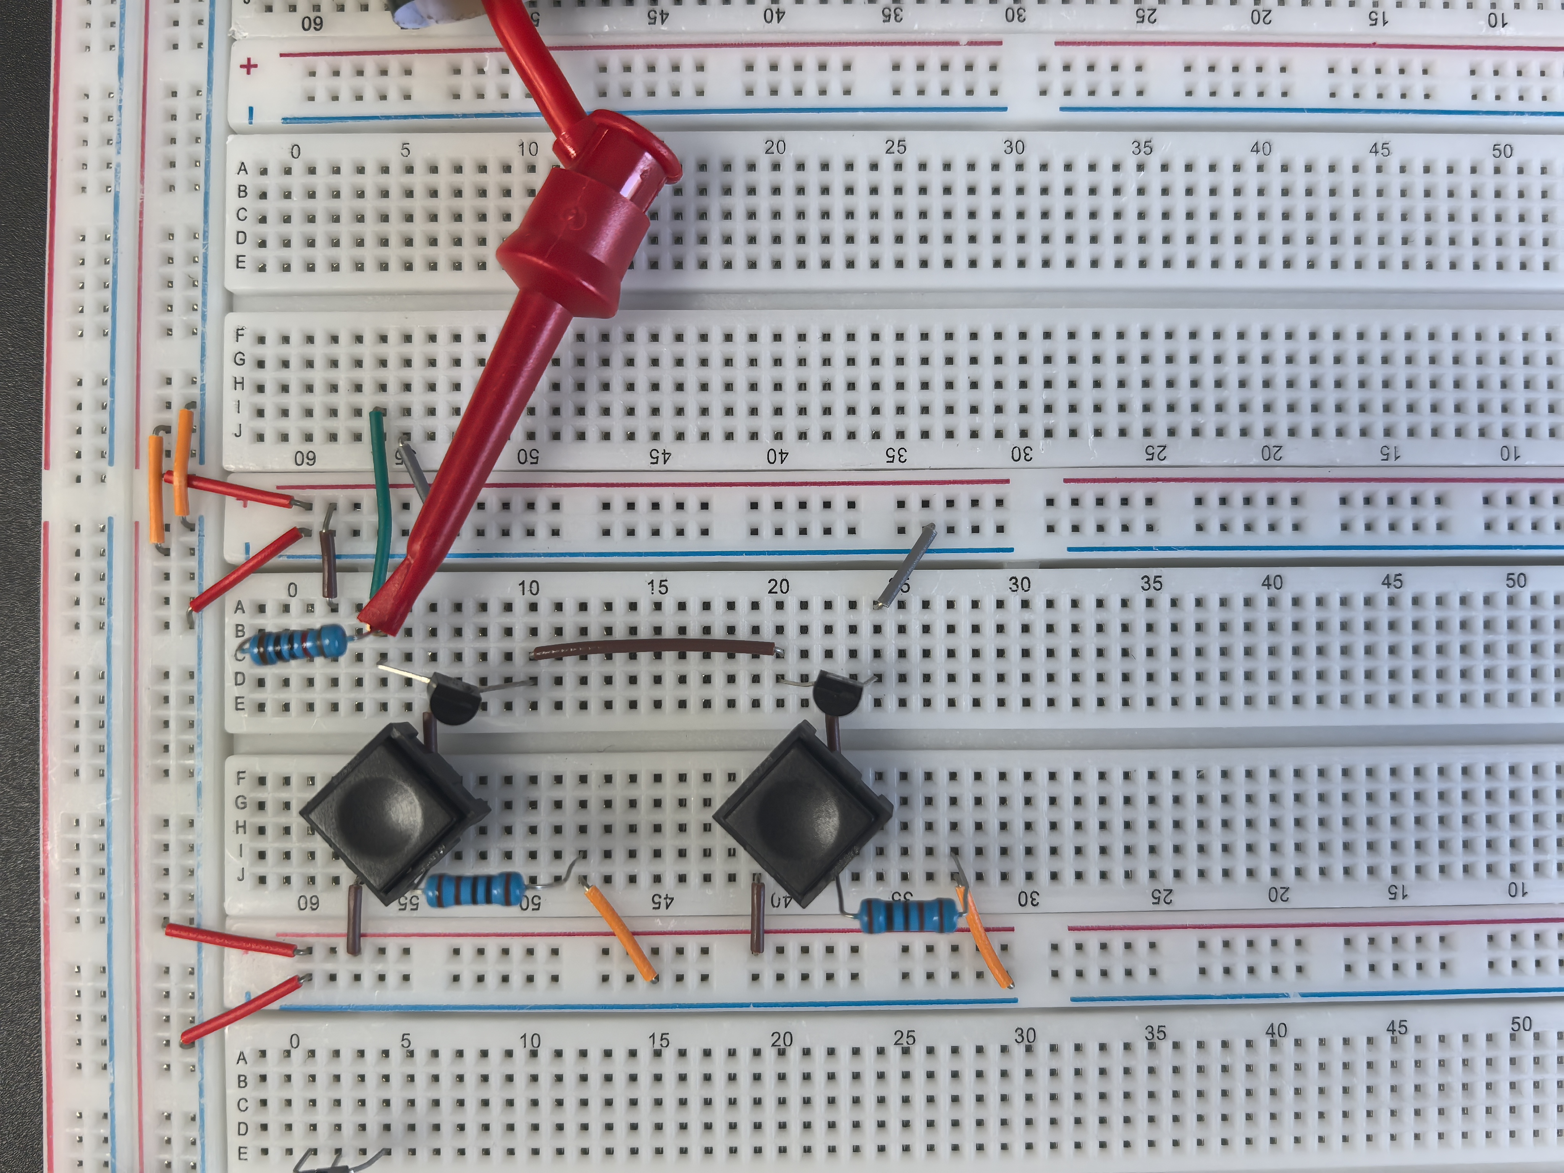

[(B) Fill out the following information] (2 points)

|  |  |  |  |
| --- | --- | --- | --- |
| S1 (A) | S2 (B) | Vout | LED (on/off) |
| Open | Open | 4.9753V | ON |
| Open | Closed | 4.9748V | ON |
| Closed | Open | 4.9752V | ON |
| Closed | Closed | 15.000mV | OFF |

[(C) Select a logic abstraction and draw a truth table for logical values (0/1)] (2 points)

Logic abstraction: NAND gate

|  |  |  |
| --- | --- | --- |
| S1 | S2 | Result |
| 0 | 0 | 1 |
| 0 | 1 | 1 |
| 1 | 0 | 1 |
| 1 | 1 | 0 |

Note: for switches (S1,S2), open is 0, close is 1; for result(LED), ON is 1, OFF is 0.

The result is 0 **if and only** if two inputs are **both** 1, which can be seen as a **NAND gate**.

**NMOS NAND Gate with R1 = 10kΩ (5 points)**

[(A) Fill out the following information] (2 points)

|  |  |  |  |
| --- | --- | --- | --- |
| S1 (A) | S2 (B) | Vout | LED (on/off) |
| Open | Open | 4.9708V | ON |
| Open | Closed | 4.9703V | ON |
| Closed | Open | 4.9703V | ON |
| Closed | Closed | 1.781mV | OFF |

[(B) Select a logic abstraction and draw a truth table for logical values (0/1)] (2 points)

Logic abstraction: NAND gate

|  |  |  |
| --- | --- | --- |
| S1 | S2 | Result |
| 0 | 0 | 1 |
| 0 | 1 | 1 |
| 1 | 0 | 1 |
| 1 | 1 | 0 |

Note: for switches (S1,S2), open is 0, close is 1; for result(LED), ON is 1, OFF is 0.

The result is 0 **if and only** if two inputs are **both** 1, which can be seen as a **NAND gate**.

[(C) Which resistor value works better in this circuit in terms of the circuit’s logic output (High/Low)? Why?] (1 point)

A **smaller resistor value (1kΩ)** works better than a larger one (10kΩ) for R1 in this NAND gate circuit.

A **smaller R1 (10kΩ)** provides **stronger pull-up capability** when the MOSFETs are off. This **ensures the output (Vout) is pulled firmly to the High level** even when driving light loads, minimizing voltage drops caused by loads.

A **larger R1 (10kΩ)** weakens the pull-up ability, making Vout  **more susceptible to voltage drops** under load, which could **blur the distinction** between High and Low levels.

[(D) Demonstrate your circuit to the TA for the first Lab 2 check-off .] (7 points)

**Part IV: The CMOS Inverter (5.5 points)**

[(A) Insert a picture of your build of the circuit] (0.5 points)

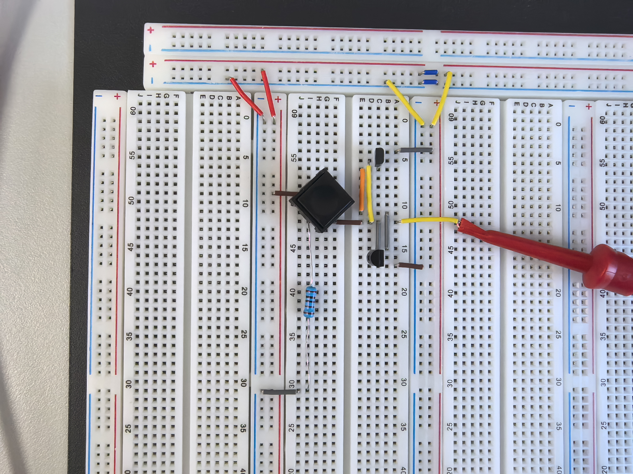

[(B) Fill out the following information] (1.0 points)

|  |  |  |  |
| --- | --- | --- | --- |
| S1 | VA | Vout | LED (on/off) |
| Open | -0.036mV | 4.9758V | ON |
| Closed | 4.9979V | 19.436mV | OFF |

[(C) Select a logic abstraction and draw a truth table for logical values (0/1)] (2 points)

Logic abstraction: NOT gate

|  |  |
| --- | --- |
| S1 | Result |
| 0 | 1 |
| 1 | 0 |

Note: for S1, open is 0, close is 1; for result(LED), ON is 1, OFF is 0.

The result is **opposed** to the input, which can be seen as a **NOT gate**.

[(D) How does one switch control 2 transistors? Under what conditions are both transistors turned on? Why?] (2 points)

Both transistors share the same control signal because **their gates(G) are connected together** and driven by the same voltage $V_{A}$.

When $V_{A}=0V$, the PMOS has a negative gate-to-source voltage and **turns on**, while the NMOS has zero gate-to-source voltage and **remains off**. When $V_{A}=5V$, the **PMOS turns off** and the **NMOS turns on**.

When $V_{A}$ is at a mid-level voltage, **both transistors meet their conduction conditions** and are **on** simultaneously.

This happens because the PMOS conducts when **its gate is lower than its source**, and the NMOS conducts when **its gate is higher than its source**.

**Part V: The CMOS NAND Gate (20 points)**

[(A) Insert a picture of your build of the circuit] (0.5 points)

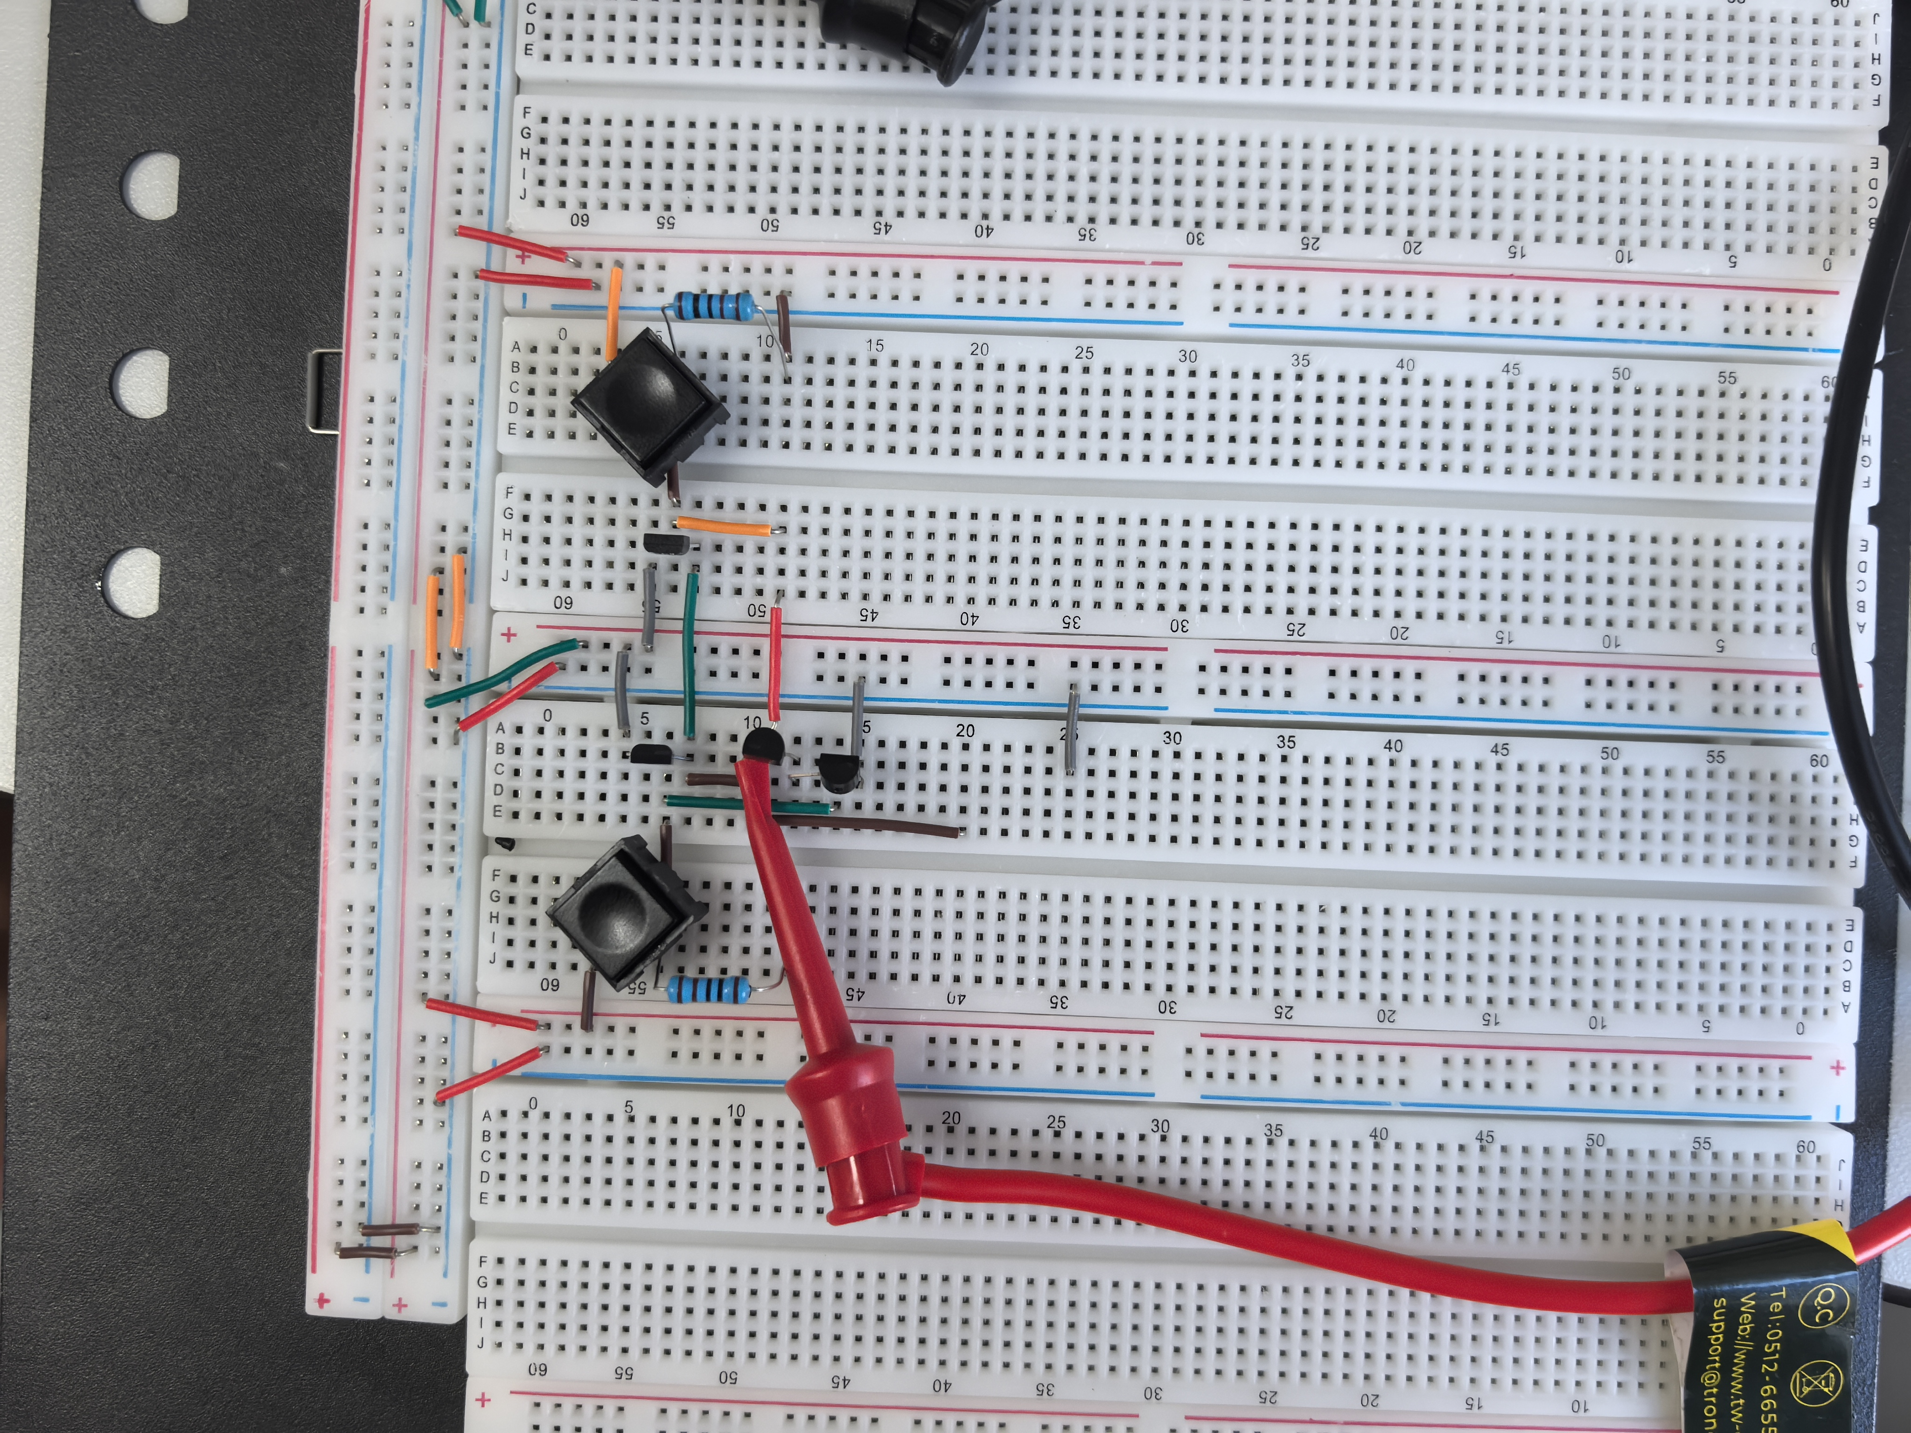

[(B) Fill out the following information] (2 points)

|  |  |  |  |  |  |
| --- | --- | --- | --- | --- | --- |
| S1 (A) | S2 (B) | VA | VB | Vout | LED (on/off) |
| Open | Open | 0.014mV | 0.991V | 4.9080V | ON |
| Open | Closed | 0.063mV | 4.998V | 4.998V | ON |
| Closed | Open | 4.909V | 0.728V | 4.907V | ON |
| Closed | Closed | 4.905V | 4.919V | 0.991mV | OFF |

[(C) Select a logic abstraction and draw a truth table for logical values (0/1)] (2 points)

Logic abstraction: NAND gate

|  |  |  |
| --- | --- | --- |
| S1 | S2 | Result |
| 0 | 0 | 1 |
| 0 | 1 | 1 |
| 1 | 0 | 1 |
| 1 | 1 | 0 |

Note: for switches (S1,S2), open is 0, close is 1; for result(LED), ON is 1, OFF is 0.

The result is 0 **if and only** if two inputs are **both** 1, which can be seen as a **NAND gate**.

[(D) What is the difference between an NMOS NAND gate and a CMOS NAND gate?] (1.5 points)

An **NMOS NAND gate** uses only NMOS transistors with pull-up resistors, so it **consumes power when it stand-by** and **cannot** drive a full logic high.  
A **CMOS NAND gate** uses both PMOS and NMOS transistors in **complementary pairs**, so it **can** drive a full logic high, and very **low static power consumption**.

[(E) Demonstrate your circuit to the TA for the second Lab 2 check-off.] (7 points)

**EXTRA PAGES**

[Leave the page unchanged if you are not going to use. Otherwise, specify the problem number you are working on here. Don’t forget to notify “TO BE CONTINUED” in the original problem box]

**EXTRA PAGES**

[Leave the page unchanged if you are not going to use. Otherwise, specify the problem number you are working on here. Don’t forget to notify “TO BE CONTINUED” in the original problem box]

**EXTRA PAGES**

[Leave the page unchanged if you are not going to use. Otherwise, specify the problem number you are working on here. Don’t forget to notify “TO BE CONTINUED” in the original problem box]